Pike County Career Technology Center
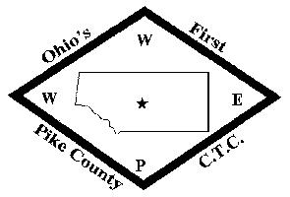
Adult Education

Plan: Retention & Completion Improvement Plan

Objective: To improve the program retention and completion rates.
The creation of this written plan will begin a process that will allow the administration, instructors, and advisory committee members to better understand and adjust program related factors and conditions that impact retention & completion rates.

Evaluated: Evaluated by the compiled and categorized student withdrawal and non-completion data.

Timeline: Annually by Adult Education Director

Plan review:
This plan will be reviewed by the Adult Education Director and annually updated as necessary. This Retention & Completion Improvement Plan provides additional information that can be considered when developing a program improvement plan for program(s) that are below 60% completion rate.

Student Performance Data:
Support staff will compile and organize data regarding the reasons why a student is leaving their program or not completing their program. These can be put into categories to help explain the reasoning behind withdrawal or non-completion (financial, grades, family issues, etc.). It is a more narrative explanation of why a student is not completing their program.

Faculty and staff input:
Compiled and organized data will be shared directly with faculty and staff members. Comments and suggestions for program improvement will be encouraged.
Student Input: When a student withdraws from a program (not dismissed) a Withdrawal Form will be completed and the reason for the withdrawal will be noted (Health, Academic, Employment Conflict, Financial, Residential, Other). These will be categorized and summarized for review.

Use of collected and compiled data - and how results will be shared:
The Adult Education Director and advisory committees are responsible for the use of the information collected to adjust programs or processes to retain students.
Collected and compiled data and information will be used by the Adult Education Director, instructors, and occupational advisory committee members to guide institutional continuous improvement initiatives.
Data will be used in the development of program completion improvement plans.

